 THE SERVANT LINK
CHURCHES UNITED TO SERVE -
COMMITTED TO MAKING A DIFFERENCE
James River Baptist Association
P. O. Box 1219, Dillwyn, VA 23936
Mrs. Marilyn Snoddy – Moderator
www.jamesriverbaptistassociation.com
Tel: 434-983-7385 Email: jrba@embarqmail.com
Hours: Monday & Wednesday 8:30 AM – 2:30 PM
____________________________________________________________________________________________________________
Volume XV May 2016 Edition V

EVENTS DETAILS

May 1 Sunday School Breakfast at First Baptist Dillwyn 9:00 AM
Baptism and Graduate Recognition Service 11:00 AM

Gideon Speaker at Gladstone Memorial 11:00 AM
JRBA Stop Hunger Now Meal Packing Event
Maysville Baptist Multipurpose Center
May 1 – 3 :00 PM

ATTENTION: VOLUNTEERS
We will need some strong folks at 2:00 PM to set up and folks to remain and help clean up after we finish packing the meals. This will be our BIGGEST Meal Packing event ever – over 33,000 meals to pack!

May 5 NATIONAL DAY OF PRAYER
At City Halls across the country, individuals will gather to pray for a religious awakening in our nation. Christians can organize their own Meet at City Hall gathering (check to see if you need a permit), but anyone can simply show up and pray. Perhaps members of your Sunday School class or church would like to join together and pray. “The National Day of Prayer is not just a vital part of America’s heritage, but is as relevant and critical today as it was at the first call by our Continental Congress in 1775. Established in public law by a joint resolution of Congress, signed by President Truman in 1952, then amended to designate the day under the 100th Congress and President Reagan in 1988, it states that: The President shall issue each year a proclamation designating the first Thursday in May as a National Day of Prayer on which the people of the United States may turn to God in prayer and meditation at churches, in groups, and as individuals. As our nation struggles with foreign and domestic threats, economic insecurity, cultural tensions, and continual challenges to basic constitutional rights, citizens of the United Sates are preparing to heed the call by our elected leaders to rise to the occasion and exercise one of their most precious freedoms – the right to gather , turn to God, and pray. Will you respond to the call? Will you pray for America?” (From Why We Pray for America by Rev. Dion Elmore, www.NationalDayofPrayer.org.)

May 6 Relay for Life – Buckingham
Enon will be sponsoring a team.

May 7 Antioch Union Baptist Women’s Annual Yard Sale, Auction & Bake Sale at Toga Fire Department 7:00 AM – 1:00 PM
Breakfast will be served at 7:00 AM. Silent Auction – 10:00 AM + Items to be Auctioned at 10:30 AM.
Lunch will be available. Spaces available to sell your items at $10 per table. If you have questions or if you would like to reserve
a space, please contact Joan Jamerson at 434-969-4476 or Lynn Perkins at 434-969-4914.
All proceeds support: Antioch-Union Baptist Church/Baptist Women’s Projects to support those in need.

Mother’s Day Tea at Enon 10:00 AM
Mother’s Day Dinner at Tar Wallet 5:00 PM

Antioch at Old Farm Day, Palmyra
Under the shade of two large tents, members will be giving away bottled water, balloons, and stickers all with the church’s logo. There will be free popcorn and snow cones, books and games for the children who stop by. 30-40 volunteers will man the tents in Antioch’s largest outreach project. They are praying for good weather! Head on out to the big event and stop by their tent.
Disaster Response Training in Wirtz/Roanoke 8:30 AM – 12:30 PM
Training in Recovery and Showers/Laundry. Go to www.bgav.org/events/disaster-response-training/ for more info/to register.

May 8 HAPPY MOTHER’S DAY TO ALL MOMS!

Mother’s Day Breakfast at Enon 8:30 AM
Breakfast prepared by the men of the church. All are invited.

Mother’s Day Celebration and Baby Dedication at First Baptist Dillwyn 11:00 AM
Recognition of Mothers at Gladstone Memorial 11:00 AM

May 9 All donated items for the Bland Ministry Center are due today at the JRBA Office.
Office will be open from 8:30 AM – 2:30 PM.
1
May 10 Virginia Baptist Historical Society Annual Meeting at the Center for Baptist Heritage & Studies
Terry Towler, FBC, representing JRBA
PUBLIC MEETING AT FIRST BAPTIST CHURCH, RICHMOND – 7:15 pm
FBC is located at the corner of Monument Avenue and the Boulevard ini Richmond. Parking is available at the eastern entrance to the church and another larger lot one block further east, as well as parking along the streets.

May 11 Senior Citizens Fellowship at Mulberry Grove 11:00 AM
Bluegrass/Gospel Music. Covered dish lunch.

Safety Training for Faith-Based Organizations at Albemarle County Police Department 8:00 AM – 4:30 PM
Places of worship are where we feel most safe, but in fact can be extremely vulnerable. The Virginia Fusion Center is providing a presentation on how religious organziations can be welcoming and also safe at the same time. Topics will include violence in places of worship, addressing potential threats, policy and planning for violence, safety in outreach, firearms in places of worship, and civilian response to active shooter events. (Information on registration was sent to churches earlier. Registration deadline was April 26 and the class is full, but if you are interested, contact Special Agent Austin White, Virginia State Police at 804-674-2237, to be put on a waiting list.) The class is free. Meals are not included, but time will be available for lunch.


JRBA Semi-Annual Spring Meeting
Thursday, May 12, 2016
Antioch Union Baptist Church (Antioch Facility)
Registration – 5:45 PM, Mission Presentation – 6:00 PM
Fellowship Supper – 6:15 PM, Worship – 7:00 PM

Preaching: Rev. David Vogt, Antioch, Scottsville
Special Music: The Fraticelli Brothers of Sharon Baptist
Theme: Romans 12:12

Supper is being provided by Antioch Union (Spaghetti, Salad, & Dessert) so no need to bring side dishes!

Directions from Dillwyn: Turn right at Sprouses Corner onto Rt. 60 West. Continue through Buckingham Court House to Mt. Rush – stay on Route 60 W. Turn right on Rt. 607 (Greenway Road). Go about 5 – 6 miles. Antioch Union will be on the left. The church is located at 2810 Greenway Road, Wingina, VA 24599

May 13 & 27 Blue Ridge Food Service Food Distribution at Crystal Cathedral, Dillwyn
Volunteers are needed at 9:30 AM.

May 13 – 15 Spring Volunteer Event at CrossRoads Camp and Conference Center
For more information, call 434-277-8465

JRBA Mission Trip to Bland Ministries
May 15 – 21, 2016
We have 13 adults currently signed up to go to the Bland Ministry Center If you have been praying about going and feel God is leading you to join us, call Phyllis at 434-983-7385 a.s.a.p.

Team Members: Dana Powers-Hamner and Jason Ballowe(Cedar), Nancy Morris (Chestnut Grove), Thelma Childress, Henry & Dixie Wood, and Rev. Jimmy Dunn (First Baptist Dillwyn), Agnes Davis (Mt. Tabor), Dorothy Davis and Brenda McAllister (Mt. Zion), Gwynn & Phyllis Tyler (Mulberry Grove), and Audrey Ragland (Sharon).
HOW CAN YOU HELP?

PRAY FOR THE TEAM, FOR THE WORK TO BE DONE, AND THAT GOD MAY BE GLORIFIED!

The following items are being collected and will be taken to Bland Ministries – please have your items in to the JRBA Office by Monday, May 9 (Office is open on Monday & Wednesday, 8:30 AM – 2:30 PM):
Peanut Butter
Plastic Shopping Bags
Campbell’s Soup Labels
Dental Floss
Copy Paper
Men’s Gently-Used Jeans in LARGER SIZES (No other clothing is being collected this year.)
Monetary contributions can be made to help with construction materials. Send checks payable to Bland Ministry Center, Attn: Dee Dee Hoosier, P. O. Box 211, Bland, VA 24315. Write “Blue Envelope Project” on the memo line of your check.

May 16 – 17 Forum at Virginia Baptist Resource Center, Richmond Monday: 10 AM – 6 PM, Tuesday: 8 – 11:15 PM
(Formerly known as Youth Ministry Forum) Theme: The Problems and Potential with Parents
Studies show that teenagers spend nine hours a day using media for enjoyment. Studies have also shown that parents are the greatest influence in the faith journey of their students. This year’s forum will focus on the crossroad between parents and social media and explore how parents can engage in the lives of their students through social media and technology. Anyone who works with teens and families will want to attend this conference. The cost is $85/person. Registration includes lunch on Monday and breakfast and lunch on Tuesday. Register online at https://vbmb.wufoo.com/forms/spring-forum-2016. For more information call Karen RAckett at 1-800-255-2428, Ext. 2243.
2
May 15 – 22 2016 Week of Prayer for Associational Missions
Theme: …let us run with endurance the race that is before us. Hebrew 12:1
Use your quiet time this week to reflect on the work of the James River Baptist Association and to pray for its members and ministries. Suggestions for consideration & prayer:
Sunday: Start Thankful – Remember the folks who have gone before us who have contributed so much to JRBA’s success.
Monday: Start Smart - Pray for Associational Leaders and Pastors to seek God and join Him in what He is doing in our communities and around the world. Boldly imagine what “new” God might do through JRBA!
Tuesday: Start Ready - Pray for the 18 member churches and their outreach ministries – the race we are running is not a sprint, but a marathon. It is a life-long process of trusting and obeying the Lord - for individuals, for churches, and for associations.
Wednesday: Pray Intentionally – Pray for the Bland Mission Team serving this week, those from Antioch who are headed to Honduras, and for the youth and adults who will be doing missions this summer.
Thursday: Pray Continuously - Pray for the ongoing JRBA Hispanic Ministry.
Friday: Pray Specifically - Pray for the local family who is serving IMB.
Satuday: Pray Specifically – Pray for Victorita Gina Vasile, JRBA WMU Project Ruth adoptee.
Sunday: Pray Specifically – Pray for individuals - by name - who are lost and need to know the Savior.

May 18 Pastors’ Huddle at First Baptist Dillwyn Noon
Pastors, plan to come and fellowship together.
May 21 Pastors’ Kayaking Trip
Call Rev. Michael Khol (434-808-2383) or Rev. Dave Vogt (434-960-7613) if interested or for more information.

May 22 Mulberry Grove Family Trip to Natural Bridge Noon

Reception for Jane Dunn at First Baptist Dillwyn Noon
Honoring Jane’s retirement from directing the FBC choir. All individuals who have sung in the choirs (of various churches)
where Jane has served are invited to attend.

May 23 INFORMATION DUE BY 9:00 AM FOR THE JUNE NEWSLETTER.
Pastors and Contact Persons: Please note the earlier due date because of Memorial Day.

May 27 Fellowship Bingo at Enon 7:00 PM
All are invited to come out for an evening of fun!
May 28 Five Loaves and Two Fish Food Ministry Meal at Antioch, Scottsville 11:00 AM – 1:00 PM
Volunteers at 8:00 AM.
May 29 5th Sunday Night Sing at Chestnut Grove 6:00 PM
Featuring the “Old Time Gospel Singers”. Refreshements will be served.

May 30 MEMORIAL DAY – THE JRBA OFFICE WILL BE CLOSED.

LOOKING AHEAD>>>

June 19 – 25 Richmond: LIVE Feeding Disaster Response Training @ Impact VA Mission Camp
Real feeding experience with BGAV Disaster Relief – feeding participants at the Impact VA, Chesterfield site.
(Phyllis: I did my last training this way and it was so much better than just doing the class part! Email Aaron Lee,
BGAV Disaster Relief Coordinator, at aaron.lee@bgav.org to register and get a time during the week to go and train.)
June 20 – 24 2016 Cooperative Baptist Fellowship General Assembly at Greensboro, NC
Sheraton Hotel & Koury Convention Center; Register now at www.cbf.net/assembly
June 23 Youth of First Baptist Dillwyn Fundraiser at Solite Landing for the Batteau Festival 4:30 PM
Selling BBQ, burgers, hotdogs, fries, drinks, and sno-cones. All proceeds will go to support their summer mission trip andother youth activiteis.
July 24 – 29 WMUV Mission Trip to Standing Rock
July 25 – 29 MC2: Mission Connection at Eagle Eyrie
Theme: Salt-N-Light (Matthew 5:13-16)
Youth and adults minister through a variety of service projects in the greater Lynchburg area ranging from VBS to construction to visitation opportunities. Age-appropriate learning opportunities for preschoolers through senior adults. Daily worship services for chldren, youth and adults are highlighted by dynamic preaching, music and missions. Participants join together for an opening night picnic, a mid-week ice cream social, and packaging meals for the Source of Light orphanage in Haiti. There will be lots of pool time, plus a talent show, volleyball tournament, Frisbee golf, scavenger hunt, night hike, and Capture the Flag!
Keynote Speaker: Darrell Cook, Baptist Collegiate Minister, Virginia Tech
More Ino/Regist at: www.EagleEyrie.org/MC2.
August 7 Homecoming at Mt. Zion
Guest Speaker: Dr. Fred Anderson
New Historical Markers, placed at historical sites on the grounds, will be dedicated.



MARK YOUR CALENDARS!
The JRBA Operation InAsMuch Missions Blitz will be on Saturday, September 24, 2016.
Start planning now for missions projects in your community.
Church OIAM Contact Persons: Give Valeria Breault a call at 434-969-4603 as soon as possible!
3

ALMOST TIME FOR V.B.S.

Buckingham Starts June 5 (Submerged - Finding Truth Below the Surface)
Cedar June 26 – 30
First Baptist Dillwyn June 27 – July 1 (Children Ages 3- 10, Completed 5th Grade) 6–9 PM
(Cave Quest: Following Jesus, The Light of the World)
Tar Wallet August 1 – 5 (Submerged – Finding Truth Below the Surface)

ATTENTION: VBS DIRECTORS
WHEN YOU SET THE DATE FOR YOUR 2016 VBS, PLEASE LET PHYLLIS KNOW.

JRBA REACHES OUT>>>

JRBA Missions Committee

- Stop Hunger Now gifts from our churches, the Chris Lewis Concert, and our Virginia Baptist Mission Board now total $9,591.14! Thanks for your extremely generous giving to this very special mission project. These gifts will be used to package 33,073 meals to feed many hungry people. Since we will be packaging more meals than ever, we will need more volunteers than ever to meet at the Maysville Baptist Multi-Purpose Center on Sunday, May 1, at 3:00 PM to help package these meals. We will also need several volunteers from each church to help unload the truck and set things up at 2:00 PM. I look forward to a great aftgernoon of mission work with you.
- Our Bland Mission Trip will take place May 15 – 21, 2016. Please pray that our mission team will bless many lives in very special ways and that we will experience the blessing that comes from serving others in Jesus’s name. (See page 2 for ways you can support this mission effort.)
- Disaster Relief – We sincerely thank each individual and each of our churches for your help in response to the tornado in the Evergreen area of Appomattox. The greatest need now is financial to provide funds for our Virginia Baptist Disaster Response Teams to begin the job of rebuilding and repair work. Please make out your checks to Baptist General Association of Virginia and put “Disaster Response – Appomattox” on the memo line of the check. Mail it to BGAV, 2828 Emerywood Parkway, Richmond, VA 23294.
- More Than Nets is a fine mission project through which Virginia Baptists have been working in Ghana to help provide and install 100,000 malaria nets in malaria-infected areas and start new churches. So far 70,000 nets have been installed and 250 churches have been planted. Thousands have come to know the Lord and been baptized. Our association and our individual churches have helped provide some funds for this mission endeavor. Our offering at the Spring Meeting on May 12 will go to More Than Nets, so let us give very generously to help complete ths project. As we give the nets, we give the Gospel!
- As mission teams go out from our churches this summer, let us be in very sincere prayer for each of them. Pray that they will bless many lives and discover the joy of truly serving Jesus.
- Operation InAsMuch will be carried out in our association on Saturday, September 24. Each of our churches is challenged to begin selecting meaningful projects to carry out for our Lord.

Sincere thanks for your fine mission work.
In Christ’s Love,
Jimmy
Rev. Jimmy Dunn, Co-Chair

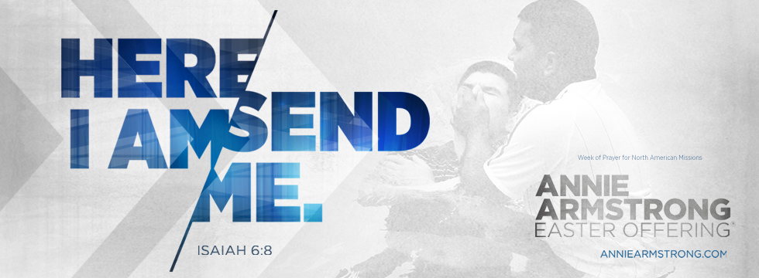
Annie Armstrong Easter Offering

CHURCH | OFFERING TO DATE
Antioch | $ 1,340.00
Buckingham | $ 2,300.00
Cedar | $ 610.00
Chestnut Grove | $ 390.00
Enon | $ 242.00
Goshen | $ 1,500.00
Jones Chapel | $ 251.00
Mt. Tabor | $ 270.00
Mt. Zion | $ 1,588.00
Sharon | $ 215.00

CHURCH OUTREACH>>>

Antioch (Scottsville) had several members who participated in the Walk for Life in Charlottesville on April 16 to raise funds for the Pregnancy Center. Kevin and Beth Helms organized the Antioch walkers team. Over $100,00 was raised in all! Laura Vogt, Jenni Clore and Angela Bishop will be leaving on a mission trip to Honduras on May 21. The April 5 Loaves & 2 Fish Ministry Meal provided a lunch of turkey sandwiches with chips, fruit, and dessert to everyone who came in and 76 food boxes were given out. The church provided items for firefighters battling a large fire – Kristie Via delivered the items. Antioch is also collecting items for a troop in Irag and seeds for Malcolm Warfield’s seed ministry.
4

Buckingham has a team of 8 going to Impact VA – Saluda in July. There will be two adults and six teens on the team.

Enon held a fundraiser for Relay for Life on April 10. They had an excellent turnout and raised $406. Everyone enjoyed great fellowship and refreshments!

First Baptist Dillwyn’s children presented “Noah’s Ark” on April 17. It was a success with 115 in attendance! FBC has been, and continues to be, involved in the tornado relief work in the Evergreen area of Appomattox through giving ($500 from a mission fund and $150 from the men’s prayer breakfast group – FBC, White Hall Methodist, and Bethlehem Baptist churches). They are also sending many needed items, including several furniture items, to the distribution center at Evergreen Baptist Church. One FBC member spent a Saturday morning helping at the center. FBC plans to receive a love offering on Sunday, May 1, to help with the continuing recovery work.

Jones Chapel is making plans for the July Mission Trip to WV and school supplies are being collected to distribute to children in need. Please pray for the volunteers as they minister and teach. Jones Chapel is also continuing to collect items for Operation Christmas Child and their goal this year is to pack 100 shoeboxes.

Mt. Zion ‘s WMU sponsored 10 Longwood and Hampton Sydney BSU students at $10 each. Children’s Missions sponsored 10 additional students – this ministry prepares Care Packages for the students during Exam week. Mt. Zion has set the date for their Fall Festival for September 24, to coincide with the JRBA Operation InAsMuch Missions Blitz.

Mulberry Grove worked on several projects throughout the month of April. Members continued to donate to the Annie Armstrong Offering for North American Missions, contribute items for the Bland County mission trip and the Heritage Hall Nursing Home, and donate snack items for the exam care packages for Longwood and Hampden Sydney. Members are very involved in reaching out to the shut-ins, the bi-lingual Hispanic Bible Study, and the bi-monthly food distribution at the Crystal Cathedral. Projects for May will include collecting school supplies for the Jones Chapel mission trip and a potato drop for individuals in need.

Sharon collected items (peanut butter, shopping bags, dental floss, copy paper, men’s jeans, etc.) for the Bland Ministry Center. Members also contributed 24 dozen homemade cookies to support the Kairos Prison Ministry, a weekend program conducted inside the Buckingham Correctional Center. Rose of Sharon continues visiting and delivering soup to those who are sick or homebound, and collecting religious study materials for donation to the prison ministry.

137 folks from Antioch (Scottsville), Arvon, Buckingham, Chestnut Grove, First Baptist Dillwyn, Goshen, Jones Chapel, Mt. Zion, Mulberry Grove, and Sharon have signed up to pack meals on May 1. If you have not signed up, please come on out and help with this mission effort. It will be a good time and a great way to serve our Lord!

OTHER EVENTS>>>

Antioch (Scottsville) held Loyalty Day on April 24. It was started sometime in the 1940’s to raise money for building and expansion. It is a long standing tradition. Worship was followed by a covered dish lunch. Antioch has a softball team, that is very active. It was started by Jessica Kirby and Pastor Dave Vogt.

Several members of First Baptist Dillwyn held the “Peace Run” peace torch during its run through Dillwyn recently.

After worship on April 10, a group of Jones Chapel’s children and adults went to Main Street Lanes in Farmville for bowling. They had a great time together, while riding on the church bus for the first time.

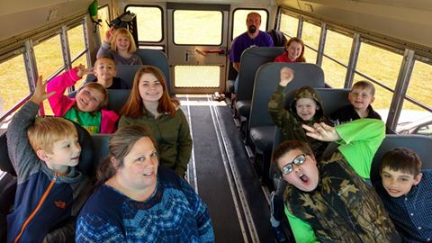



On April 16, the men of Jones Chapel prepared a pancake supper for everyone. Yummy pancakes, sausage, bacon, eggs, biscuits, gravy, fried apples, and more was served and enjoyed by everyone. Afterwards, the kids enjoyed a movie while the adults watched the movie, Do You Believe?

Mulberry Grove held a movie/pizza night on April 8. It was well attended by the young and young at heart. A meal of pizza, salad, and desserts was enjoyed by everyone. It was a wonderful time of fellowship. Adults viewed the movie, War Room, while the children had crafts, games, and a movie of their own.

JRBA LEARNS AND GROWS>>>

Buckingham’s revival (April 24 – 27) experienced wonderful crowds and folks liked Jerry Gray, the speaker. Five of the Buckingham women attended the Farmville Women’s Retreat on April 22. Attending were Eleanor Newton, Angie Robertson, Susie Taylor, Betty Toney, and Patricia Woodfin. They especially enjoyed Rachel Price, the speaker for the event.

The Youth of First Baptist Dillwyn led the worship service on April 24.
One church member was blessed to attend the Pro Life gathering at Charlottesville’s Planned Parenthood on April 23.

Upcoming sermons at Gladstone Memorial:
May 15 – Why Read the Bible? Reasons to Read the Bible
May 22 – Why Read the Bible? The Fruit
May 29 – Communion & Why Read the Bible? Adding

Dorothy Davis and Marilyn Snoddy, Mt. Zion, attended the women’s Retreat in Farmville on April 22. The speaker told of her experience with cancer and how God used it to show her how to “Sing in the Dark”. It was a very inspiring message, and wonderful worship.
Mt. Zion sent a group to Mom & Me, except they changed it to Mom & Me & Grandma! Brenda McAllister and granddaughter, Rosalyn Miglucci, Doris Roberts and granddaughters, Christy and Lily Shumaker, attended. They took a large box of stuffed toys that were collected for little children going through scary times.
5
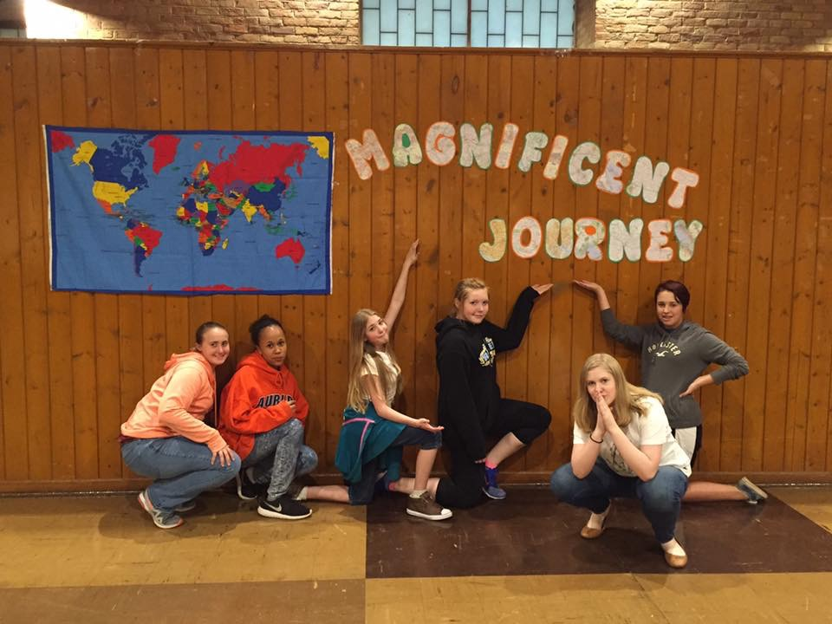

Girls from Mt. Zion & First Baptist Dillwyn

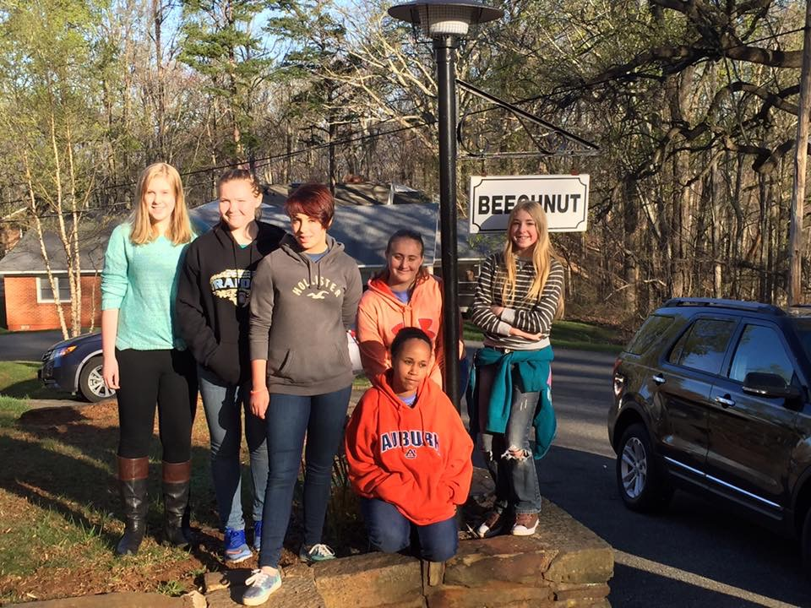

Mt. Zion took a group of 6 girls and 2 adults to Shine Girls Weekend Retreat on April 8 - 10. Those attending were Jessica Oliver, Jaycee Call, Mariah Chambers, Alyssa Clark, Dorothy Davis and from First Baptist Dillwyn, Kristye Moxley and her daughters, Leah and Eve. The theme for the weekend was Magnificent Journey with the focus scripture being Luke 9:57: As they were walking along the road, a man said to him, “I will follow you wherever you go”. Friday evening the group gathered for a meet and greet with other girls, played games, and watched the movie, War Room. During the weekend they participated in Bible study and several choices of breakout sessions including Mission Crafting, Self Defense, How to Live as a Daughter of the King on our Royal Journey, Learning to Follow God’s Path for Us in Every Step I Take, and Spending time in Reflection, Prayer, and Developing a Personal Prayer Strategy in our War Room. The mission project for the weekend was collecting items for Teen moms and their babies. On Saturday they attended a baby shower complete with cake and snacks! All he items the girls had collected were laid out for display. Everyone made a circle around the items and prayed for the moms and babies that would receive the items. Saturday there were snow showers during the day which was a first for everyone at Shine! Throughout the weekend, time was spent together in worship. Music was led by Children of Thunder. The keynote speaker, Kathy Kim, Multicultural Counsel Representative to the Board of Trustees, WMUV, gave inspirational messages. She used many object lessons to reinforce her points. Saturday night’s worship was simply amazing and the Holy Spirit was moving among the participants! At night the group gathered in their cabin and each girl led in a devotion of her choosing and they discussed the events of the day and prayed together. Each one was truly blessed by their experience on the mountain and pray that God will use what they learned to guide them on their Magnificent Journey as they seek to serve Him more! Dorothy noted that this was the best Shine weekend she has attended – from the breakout session choices to the music and speakers, everything was so well done! For those who have never attended this event, she encourages you to make plans for next year.

JRBA Pastors’ Huddle

On April 20, our pastors met for the Pastors’ Huddle. It was nice to welcome two new pastors from our association: Geoff Bruschi (Arvon) and Don Campbell (Interim – Mt. Zion). Eight pastors representing seven different churches in our association were in attendance. It was very exciting seeing this spirit of unity and love. Our next huddle will be on Wednesday, May 18, at First Baptist Dillwyn. Also, there is a Kayaking trip being scheduled for the pastors on May 21. If you are interested, please contact me or Dave Vogt* to R.S.V.P. We are planning on meeting at Antioch (Scottsville), at 8:00 AM that morning.
Michael
Rev. Michael Khol
*Michael 434-808-2383
Dave 434-960-7613

JRBA WMU Annual Meeting

The Annual Meeting of the JRBA WMU was held at Mt. Zion on Sunday, April 17, with 35 in attendance from 8 churches. The offering was $200 which will be sent to CrossRoads Camp and Conference Center for the building project. Special music was provided by Nancy Morris (Chestnut Grove). After the minutes and treasurer’s report was approved as printed, Nancy Morris briefly went over the Missions Report. She stated that the number of churches reporting was down from 9 last year to 8 this year and though the activities were numerous, the missions giving was down to $36,464 from almost $75,000 last year. We need to have all the churches reporting. The attendance banner was presented to the members of Mt. Zion ,with 13 members present, by Angie Robertson. The banner for the church with the most miles walked was presented by Audrey Ragland to Mulberry Grove with 4,801 miles and the trophy for the person with the most miles went to Rev. Michael Khol with 1,085 miles. The WMU is keeping up their health. Betty Toney introduced the speaker, Linda Blair Milton, Church Relations Coordinator for Operation Christmas Child Shoe Box Ministry for the Lynchburg region. Linda gave information on what to include and what NOT to include in the boxes, the advantages of using the ministry boxes, and many interesting facts about her involvement. She showed the magazine the children receive called, “The Journey”. Over 3 million children have responded to its message and received Jesus. Another booklet given to small children depicting the plan of salvation in picture form was explained. Everyone went home determined to fix more shoeboxes this year!

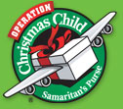

PLEASE NOTE THAT TOOTHPASTE AND CANDY ARE NOT TO BE INCLUDED IN SHOEBOXES THIS YEAR.

If your church has already collected toothpaste, you might want to bring it to JRBA and we will take it to the Bland Dental Ministry. They did not request toothpaste this year, but they do give it out to every patient that is seen so it will be put to good use.

6

JRBA CELEBRATES>>>

Antioch (Scottsville) announces the election of two new church trustees: Travis Rittenhouse and Sherron Pace. The church appreciates their willingness to serve!

Cedar welcomes into their church family Wayne and Terry Anderson through transfer of letters.

On May 22, Enon will hold a Graduate Celebration Luncheon for Emily Scott. Congratulations, Emily!

On Sunday, May 1, First Baptist Dillwyn will recognize six high school and college graduates during worship. They will also celebrate the ordinance of baptism with Hunter Seay as the baptismal candidate. On Sunday, May 8, they will celebrate Mother’s Day and have a Baby Dedication. FBC has recently gotten a new Organ/Keyboard and it will be dedicated during a Sunday morning service. FBC welcomes Kristye Moxley as their new choir director on May 8. On May 22, a reception will be held after worship to honor Jane Dunn for her 11+ years of service as their choir director.

STRAIGHT STREET NEWS>>>

Straight Street-Buckingham, Inc. is collecting items for the Back to School distribution held in late July or the early part of August. Church groups or interested individuals are encouraged to collect school items during the summer months.

Straight Street is also looking for the names of local Christian musicians or groups to perform for a possible future event. For more information or details contact Michelle at 434-983-1745 or Kathy at 434-547-2949.

FOR YOUR INFORMATION>>>

- If a work day is planned at your church and you need some helpers, please call Robyn Allen at 434-392-8920. Robyn works for VASAP (Virginia Alcohol Safety Action Program). They have individuals who need to complete community service. She needs two weeks notice to schedule workers for your event.
- If you are near retirement age and would like to attend a retirement seminar, there is one scheduled in Richmond on May 10. It will be held at the Virginia Baptist Resource Center. Call 1-800-255-2428 for information.

STAFF CHANGES – CORRECTION>>>

- The email address given last month for Arvon’s new pastor, Rev. Geoff Bruschi, was inaccurate. His email address is revgbb@hotmail.com.
- Rev. Stephen Donahue has completed his pastorate at Mt. Tabor. His last Sunday was April 10. JRBA extends our hearty blessings to him and his family.


JRBA Executive Board Summary
April 11, 2016

Moderator, Marilyn Snoddy, opened the meeting with some inspirational words based on Exodus 34:14. Do not worship any
other god, for the Lord, whose name is Jealous, is a jealous God.
God’s name is Jealous! When Moses went up on the mountain and received the tablets, the people were soon worshipping the golden calf. The people took their eyes off the one true God and began worshipping idols. Do we also do that? When we take our eyes off of God, we begin to worship other things. We need to keep our eye on God, worshipping Him and giving Him the glory! We had such a good start to our Stop Hunger Now event by holding the Chris Lewis concert, worshipping and praising God together. We should do that with every event, taking the time to honor and praise God. “We” are not accomplishing things, God is, and He deserves the praise. Hopefully, we will include worship and praise in connection with our Operation InAsMuch event this year, too. Marilyn then closed with prayer for God to help us stay focused on Him and His will.

The meeting was called to order and Frank Breault, Clerk, had the roll call of churches. There were 26 in attendance from 11 member churches. The minutes of the January Executive Board Meeting were presented and approved. Tommy Joe Steger, Jr., Treasurer, gave the quarterly Treasurer’s Report. As of March 31, 2016, the JRBA Checking Account had a balance of $36,281.00. This balance includes the following designated monies: Additional Missions Fund - $278.00, Youth Encounter - $400.00, Local Missions - $170.04, Hispanic Ministry - $920.42, and Stop Hunger Now - $9,197.42. Total receipts for the quarter were $13,056.00 (including Stop Hunger Now). Total Disbursements were $8,409.37 (including $100 to Antioch’s Flint, Michigan Water Project, $400 to BGAV Disaster Response-Appomattox, and $175.20 for mileage, Hispanic Ministry). The Treasurer’s Report was approved. Tommy Joe noted that additional funds had been received for Stop Hunger Now and the new total is $9,448.76. Funds will be accepted through April 25.

Mrs. Betty Toney presented the Benevolence Fund report for the quarter. Two individuals were provided lodging (domestic disputes), two families received donations after losing everything in house fires), four families have been assisted with overdue electric bills, one family was assisted with a Food Lion voucher to provide food, and a donation of $25 was made to the Dillwyn Fire Department as it serves the JRBA office area. Disbursements totaled $754.60. Contributions totaled $836.52. The checking account balance (3/31/16) stood at $3,418.91.
The report was approved.

Marilyn then gave the Moderator’s Report She welcomed Rev. and Mrs. Geoff Bruschi (Arvon) and Rev. and Mrs. Don Campbell (Mt. Zion). She updated us on the upcoming Stop Hunger Now event scheduled for May 1. Additional funds have come in and our updated total (as of April 11) is $9,448.76 – this will pack 32,582 meals. The World Hunger Fund of the Baptist General Association of Virginia donated $500 to our event. With the packing of more meals, we will need more volunteers so she asked that everyone encourage folks in their churches to participate. Funds and the number of volunteers from your church are due to the JRBA office by Monday, April 25. Marilyn updated us on the Bland Mission Trip planned for May 15 – 21. We have 13 signed up and have room for 2 more to participate. The team will work with food ministry, clothing ministry, dental clinic, and the construction team will be doing at least two handicapped ramps. Items being collected (plastic bags, peanut butter, Campbell’s soup labels, dental floss, copy paper, and men’s jeans in large sizes) are due to the JRBA office by May 9. 7
The Program Committee presented the program for the spring meeting along with a recommendation that the offering be donated to BGAV’s More Than Nets project. The program and recommendation were approved. The Nominating Committee presented the Slate of Officers for 2016-2017 as follows:
Moderator – Mrs. Marilyn Snoddy
Vice Moderator – Rev. Richard Tuttle
Clerk – Mr. Frank Breault
Treasurer – Mr. Tommy Joe Steger, Jr.
Reporter/Historian – Mr. Terry Towler
Sunday School Director – Rev. Perry Clore
Discipleship Director – Rev. Doug Adams
Baptist Men’s Director – Rev. John Moxley
VBS Team Leaders – Frank & Valeria Breault
Music Director – VACANT
Disaster Relief Coordinator – Rev. David Vogt
BCM Longwood Representative – Mrs. Gale Moss
VA Baptist Historical Society Rep. – Mr. Terry Towler
Parliamentarian(Appointed by Moderator) – Mr. Gwynn Tyler
WMU Director (Elected by JRBA WMU) - Mrs. Betty Toney
Currently serving with the BGAV Mission Council:
Rev Doug Adams, Rev. Perry Clore, Rev. Jimmy Dunn, Chris Moss, Judy Ownby, and Gwynn Tyler.

The Slate of Officers was approved as presented.

Rev. Michael Khol presented the Missions Committee Report. He reiterated the information on Stop Hunger Now. He also reported on the Hispanic Ministry. It is now mainly serving two families who work at Frida’s, but many more are being reached through those two families. The Bi-Lingual Bible Study continues on Thursday nights. Recently, the participants took the Hispanic children to the movies while they were on their spring break from school. Michael thanked everyone for their continued prayers and support of this ministry. His dream is to hold Hispanic worship services at some point . He has also been leading Hispanic worship at the Buckingham Correctional Facility a couple of times a month. The inmates have been very receptive. Some knew the Lord prior to their imprisonment and others have come to the Lord while there. He said he is teaching but also learning from them. One highly functioning Autistic young man is just on fire for the Lord! Michael covets your prayers for this ministry as well. He also reported that he has now been to nine of the 18 churches to dialog about the association and how churches can be more involved. He feels that we are doing a lot and can do even more to “accomplish more together than we can apart”. He does not have any more church commitments for him to come, but encouraged any church that has not participated yet to do so. He hopes to schedule an association-wide event sometime this summer.

Valeria Breault reminded everyone what Operation InAsMuch is all about – holding a day of outreach events and activities in our communities. She made a motion that this year’s event be held on September 24, 2016. It was seconded and approved. She also asked that each church send her a person’s contact information (who will be the OIAM contact for your church) as soon as possible. Mrs. Betty Toney gave a WMU update on the backpack ministry. We continue to do 20 backpacks and she reported that the primary school reports that now every child who is needy is being served by Backpacks of Love and JRBA WMU. She appreciates those who have taken part. She reminded everyone of the WMU Annual Meeting scheduled for April 17.

Marilyn presented the Christian Life Report. Michelle Wright reports that the B.C.H.S. Baccalaureate will be held on Sunday, May 1, at 4:00 PM. Rev. Rick Caldwell and Matt Allen will be the speakers. Judy Chambliss reports that plans are in the making for the Cumberland Baccalaurette. JRBA will provide refreshments for both events.

The annual review of the decision to table hiring a Director of Missions was brought up. A motion was made, seconded, and approved to discontinue the annual review since we do not have the funds available for this position. We will continue under the current leadership format.

Announcements were then made and the meeting was adjourned with prayer by Rev. Perry Clore.

FROM OUR MODERTOR>>>

I want to thank Phyllis for all her hard work in lining up all the events for the JRBA. I know she says it’s her job, but she goes above and beyond in everything.

A big THANK YOU to Rev. Jimmy Dunn for promoting Stop Hunger Now. Two things I know are near and dear to his heart are hunger and Hispanic ministry. Thank you to everyone who has contributed or plans to participate in the meal packing to make this effort a huge success.

Looking forward to our JRBA Spring Meeting on May 12. Hope to see all of you there.
In His Love,
Marilyn
Marilyn Snoddy


KEEP IN PRAYER>>>

- Those who are lost and need to know the Savior
- Churches without a pastor: Antioch Union, Chestnut Grove, Fitzgerald (Rev. David Peppler, Sr., Interim), Goshen, Mt. Tabor, and Mt. Zion (Rev. Don Campbell, Interim)
- JRBA Pastors
- JRBA Hispanic Ministry (Bi-Lingual Bible Study & Prison Ministry)
- JRBA Bland Mission Trip – May 15 – 21
- Antioch (Scottsville) Ladies on Mission Trip to Honduras, starting May 21
- Jones Chapel planning summer mission trip to WV
- Buckingham Team to Impact, VA during summer
- Upcoming VBS, Homecomings, & Revivals
- Victorita Gina Vasile, JRBA WMU Project Ruth adoptee
- Local family serving IMB
- All those in our congregations who are ill or have lost loved ones
…the prayers of the righteous please Him.
Psalm 15:8b

8

ASSOCIATION FINANCES
2015 – 2016
Regular Budget Receipts
Church | April | Year-to-Date
Antioch(Scottsville) | $ 300.00 | $ 600.00
Antioch Union
Arvon |  | $ 1,362.00
Buckingham |  | $ 930.60
Cedar |  | $ 2,000.00
Chestnut Grove |  | $ 500.00
Enon
First Baptist Dillwyn | $1,000.00 | $1,000.00
Fitzgerald Memorial
Fork of Willis |  | $ 429.00
Gladstone Memorial | $ 331.25 | $ 993.75
Goshen |  | $1,257.00
Jones Chapel | $ 123.18 | $ 816.46
Mt. Tabor |  | $ 730.00
Mt. Zion |  | $1,800.00
Mulberry Grove |  | $2,300.00
Sharon | $ 391.00 | $1,173.00
Tar Wallet
Individuals |  | $ 100.00
VBMB – Alma Hunt |  | $ 169.30
TOTAL | $2,145.43 | $16,161.11
Approved Budget for 2014 – 2015: $24,671.00

TREASURERS: Please note that unless a specific ministry or project is designated on the memo line of the check or in an accompanying note, the contribution will appear in the regular budget receipts.

ADDITIONAL MISSIONS FUND
No contributions or expenditures in April.
Earlier individual contribution: $100 (More Than Nets)
Earlier expenditures: BGAV More Than Nets - $400
BGAV Carolina Flooding - $300
Antioch Flint Water Project - $100
Balance: $278.00

YOUTH ENCOUNTER
Carryover: $400.00
No contributions or expenditures in April.

LOCAL MISSIONS PROJECTS FUND
Carryover: $258.04
No Contributions or expenditures in April.
Earlier Contributions: ½ Fall Meeting Plate Offering - $212.00
Individual - $100.00
Earlier Expenditure: BGAV Disaster Response- Appomattox $400.
Balance: $170.04

BGAV SYRIAN REFUGEE CRISIS
½ Fall Meeting Plate Offering: $212.00
October Expenditure $212.00

JRBA Hispanic Ministry

Church | April | Total-to-Date
Carryover (2014-2015) |  | $ 850.82
Buckingham |  | $ 200.00
Enon |  | $ 100.00
Mulberry Grove |  | $ 100.00
TOTAL |  | $ 400.00
No contributions in April
Disbursement – Rev. Michael Khol – Feb./Mar./Apr. - $185.52
Balance: $ 734.90

2016 Stop Hunger Now Event

Church | April | Total-to-Date
Antioch
Antioch Union |  | $ 400.00
Arvon
Buckingham |  | $ 479.00
Cedar |  | $ 831.91
Chestnut Grove |  | $ 530.00
Enon |  | $ 300.00
First Baptist Dillwyn |  | $1,738.05
Fitzgerald Memorial
Fork of Willis
Gladstone Memorial | $ 129.00 | $ 591.00
Goshen |  | $ 855.00
Jones Chapel | $ 142.38 | $ 512.75
Mt. Tabor
Mt. Zion |  | $ 600.00
Mulberry Grove |  | $ 582.15
Sharon | $ 122.34 | $ 416.31
Tar Wallet |  | $ 300.00
Individuals |  | $ 100.00
Benefit Concert |  | $ 854.97
Virginia Baptists |  | $ 500.00
TOTAL | $ 393.72 | $9,591.14*
Total includes all funds given after the May 2015 event .
*Funds contributed will pay for 33,073 meals!

John E. Mann, Sr. Benevolence Fund

Church | April | Total-to-Date
Buckingham |  | $ 200.00
Cedar |  | $ 300.00
Enon |  | $ 186.52
First Baptist Dillwyn |  | $ 500.00
Mt. Zion |  | $ 100.00
Goshen |  | $ 250.00
Mulberry Grove |  | $ 300.00
Sharon |  | $ 200.00
TOTAL |  | $2,036.52
March Disbursements: $ 100.00
Balance on Hand: $ 3,318.91*
*Error corrected from bank statement since last newsletter.

NOTICE FOR JUNE
If anyone is interested in attending the Commissioning Service for the IMB this June, it will be on Friday, June 10, 2016, at
10:30 AM. Go early so you can get a seat. The address is:
International Learning Center
6492 MLC Lane
Rockville, VA 23146.

9

